# Model structure

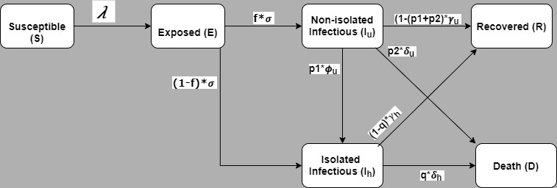

Figure 1: Model structure

# Model description

Fig 1 presents the model structure. The model simulates an open population i.e deaths due to COVID 19 are not replaced, however, births deaths due to other causes were not considered assuming the epidemic will cover a shorter period. Susceptible (S) individuals are dynamically infected, with the force of infection ($λ$), infectious non-quarantined ($I_{u}$) and infectious isolated ($I_{h}$) cases. Following infection, individuals enter the non-quarantined Exposed compartment ($E$), from which they may progress at a total rate of $σ$ to one of the two infectious compartments ( $I_{u}$ or $I_{h}$ with respective proportions of $f$ and $1-f$). Individuals with non-quarantined infectious disease ($I_{u}$) may be isolated at a rate of $ϕ_{u}$, or may self-recover at a rate of $γ_{u}$,or die due to COVID 19 complications at a rate of $δ_{u}$. Infectious individuals who are isolated ($I_{h}$) may recover at a rate of $γ_{h}$,or die due to COVID 19 complications at a rate of $δ_{h}$.

|  |  |
| --- | --- |
| **State variable** | **Description** |
| $$S$$ | Population of susceptible individuals |
| $$E$$ | Population of quarantined exposed individuals (infected but  not showing symptoms and cannot transmit infection) |
| $$I_{u}$$ | Population of symptomatically-infectious  (non-hospitalized/isolated) individuals |
| $$I_{h}$$ | Population of symptomatically-infectious isolated  (self/hospitalized) individuals |
| $$R$$ | Population of recovered individuals |
| $$D$$ | Population of died individuals (not shown in the Figure1) |

$$N\left(t\right)= S\left(t\right)+ E\left(t\right)+ I_{u}\left(t\right)+ I_{h}\left(t\right)+ R\left(t\right)+D(t)$$

**Model equation**

$$\frac{dS}{dt}= -λS$$

$$\frac{dE }{dt} = λS- σE$$

$$\frac{dI_{u}}{dt} =(1-f)σE - \left({(1-\left(p1+p2\right))γ}_{u} + {p1ϕ}_{u} + {p1δ}_{u}\right)I_{u}$$

$$\frac{dI_{h}}{dt}= fσE + {p1ϕ}_{u}I_{u} - \left((1-q)γ_{h} + qδ_{h}\right)I_{h}$$

$$\frac{dR}{dt}= {(1-\left(p1+p2\right))γ}_{u}I_{u} + {(1-q)γ}_{h}I_{h}$$

$$\frac{dD}{dt}= p2δ_{u}I_{u} + {qδ}_{h}I_{h}$$

*̇*

*̇*

where *force of infection $λ$* is defined as:

$$λ =\frac{β(S_{D})\left(1-ϵ_{M}c_{M}\right)\left(I_{u} + η_{h}I_{h}\right)}{N }$$

Model parameters required

|  |  |  |  |
| --- | --- | --- | --- |
| **State variable** | **Time in the compartment** | **Value(range)** | **Source** |
| $$E$$ | Incubation period in days |  |  |
| $$I_{u}$$ | Infectious period in days |  |  |
| $$I_{a}$$ | Infectious period in days |  |  |
| $$I_{h}$$ | Hospital stay period in days |  |  |
| $$ϵ_{M}$$ | Efficacy of face-masks to prevent acquisition of infection by susceptible individuals (0 to 1) |  |  |
| $$c_{M}$$ | Proportion of members of public who wear masks in public (i.e., masks compliance) (0 to 1) |  |  |
| $$S_{D}$$ | Social distancing effectiveness in proportion (0 to 1) |  |  |
| 1-f | Proportion of exposed individuals move to the isolated infectious class at the end of the incubation period (0 to 1) |  |  |
| $$η_{h}$$ | Relative infectiousness of hospitalized/isolated infectious humans in relation to symptomatic non-quarantined individuals (0 to 1) |  |  |
| $$ϕ_{u}$$ | Isolation rate of non-quarantined infectious individuals  OR  Average delay in days to detect and isolate cases |  |  |
| P1 | Proportion of cases detected during their infectious period  OR Case detection rate (0 to 1) |  |  |
| $$P2$$ $$δ_{u}$$ | Proportion of non-isolated cases died (0 to 1) |  |  |
| q $$δ_{h}$$ | Proportion of isolated cases died (0 to 1) |  |  |
|  | Proportion of non-isolated cases died (0 to 1) |  |  |

Detail model parameters

|  |  |  |  |  |  |  |  |
| --- | --- | --- | --- | --- | --- | --- | --- |
| **Symbol** | **Description** | **Source [Ref]** | **Baseline value (**just to run the model**)** | **Range of value for sensitivity analysis** | **Intervention type** | **Intervention average size/ effect on the parameter** | **Intervention size range** |
| R0 | Basic reproductive number | Data |  |  |  |  |  |
| $$β$$ | Community effective contact rate per person per unit time (to be reduced by social distancing measures) | Calculated from R0 | 1.1per day |  |  |  |  |
| $$S_{D}$$ | Social distancing | **Intervention** |  |  | Social distancing | Reduction in $β$ | 0-0.4 |
| $$f$$ | Proportion of exposed individuals move to the non-quarantined infectious class at the end of the incubation period | Data/expert opinion | 0.4 |  |  |  |  |
| 1-f | Proportion of exposed individuals move to the isolated infectious class at the end of the incubation period | Calculated | 0.6 |  | Contact tracing (CT) |  |  |
| $$ϵ_{M}$$ | Efficacy of face-masks to prevent acquisition of infection by susceptible individuals | Basic research | 0.5 |  | Increasing mask efficacy 0.25-0.75 |  | 0-1 both CM and EM on R0 with heat map |
| $$c_{M}$$ | Proportion of members of public who wear masks in public (i.e., masks compliance) | **Intervention** | 0.0576 |  | Increasing mask coverage 0-50% |  |
| $$η_{h}$$ | Relative infectiousness of hospitalized/isolated infectious humans in relation to symptomatic non-quarantined individuals | Assumed | 0.2 |  |  |  |  |
| $$σ_{}$$ | The rate at which exposed non-quarantined individuals progress to the symptomatic and asymptomatic infectious classes | From incubation period | 1/incubation | 2-14days |  |  |  |
| $$ϕ_{u}$$ | Hospitalization rate of non-quarantined infectious individuals | **Intervention** | 1∕delay |  | Confirmed case isolation |  |  |
| $$δ_{u}$$ | The COVID-induced mortality for  individuals in the non-quarantined infectious class | Estimated from proportion of death | 0.015 per day |  |  |  |  |
| $$δ_{h}$$ | The COVID-induced mortality for  individuals in the isolated infectious class | Estimated from proportion of death | 0.015per day |  |  |  |  |
| $$γ_{u}$$ | The recovery rate for individuals in the non-quarantined infectious class | Estimated from proportion of recovery and infectious period |  |  |  |  |  |
| $$γ_{h}$$ | The recovery rate for individuals in the isolated infectious class | Estimated from proportion of recovery and hospitalisation period |  |  |  |  |  |

# names of parameters for R

|  |  |
| --- | --- |
| **Symbol** | **In words** |
| $$β$$ | beta |
| $$f$$ | f |
| $$1-f$$ | 1-f |
| $$ϵ_{M}$$ | E_M |
| $$c_{M}$$ | C_M |
| $$η_{h}$$ | eta_h |
| $$σ_{}$$ | sigma |
| $$ϕ_{u}$$ | phi_u |
| $$δ_{u}$$ | delta_u |
| $$δ_{h}$$ | delta_h |
| $$γ_{u}$$ | gamma_u |
| $$γ_{h}$$ | gamma_h |

# RESULTS

## Estimation of R0

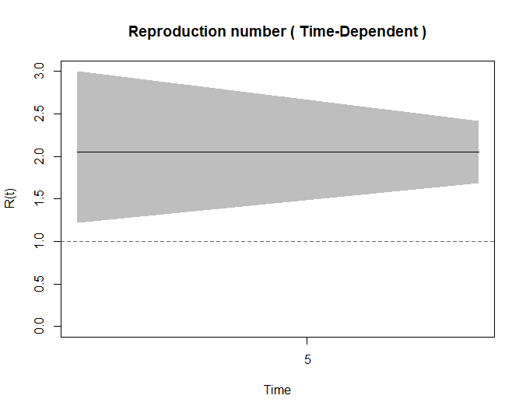

Smoothed for week

### Estimation of infectious cases for R0

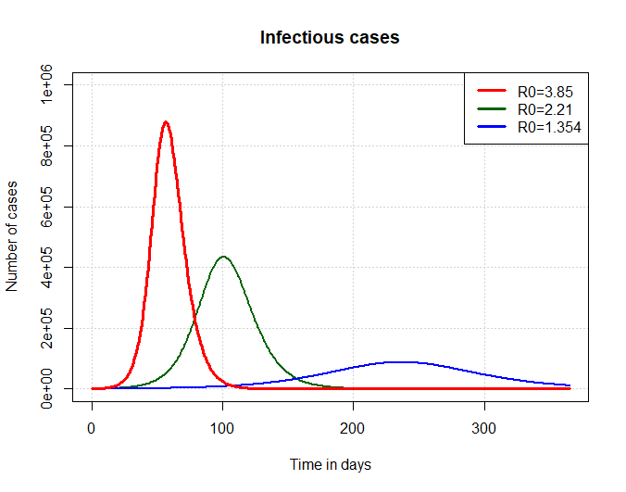

### Estimation of deaths cases for R0

